A Guide to Designing Lessons or Courses in the Health Professions

Robert Parson, M.Ed.Directeur, Formation et agrément/Director, Education and Accreditation
Développement professionnelle continue/Office of Continuing Professional Development
Email: rparson@uottawa.ca

Introduction
This guide has been designed to be used as part of an instructional design workshop but can also be used independently for course or module design. Use the following tables and exercises to help guide you through the design and development of courses, lessons or curriculum for medical education, other health education fields, or for continuing professional development (CPD).
This design process is based principally on the work of Kern (2009) and Diamond (2008) with substantial input from professional and educational development colleagues from Canada and abroad. The following graphic illustrates the steps to the design of an education program. The components of the process will be discussed further in the following pages.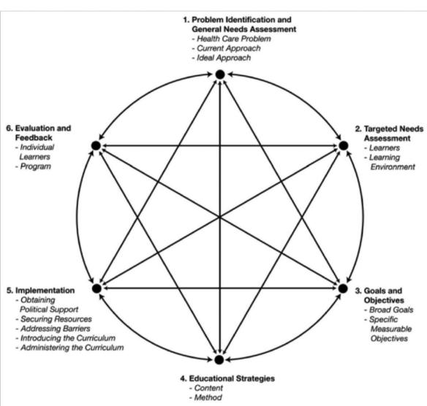
Kern, D.E., Thomas, P.A. and Hughes, M.T. “Curriculum Development for Medical Education: A Six Step Approach” (2009) Second Ed.

1.Problem Identification and General Needs Assessment
Please note: It is understood that some or many of these steps will vary in terms of sequence and are open to revision. For example, you may have some data that points you to defining the problem and identifying the gap, but as you build your lesson, you realise that more data is needed. This is completely normal.
The steps in this section are:
- Define the health care problem and describe the need
- Identify the context around the need
- Describe your target learners
- Write a synthesis of the gap or need

a) Define the Health Care Problem and Describe the Need
The goal of this step is to describe the "health care problem" that this learning activity is addressing. Begin with looking at the “whole” before zeroing in on the specifics.
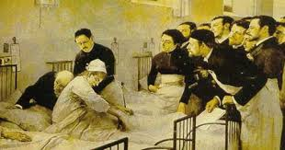
Subject or a topic that you will address: ___________________________________________

Consider, then document:
Who is affected? Stakeholders could include…
- Patients
- Medical personnel
- Society

Instructions
Keep in mind that many of these steps will not be in the following sequence. For example, you may search the literature, identify a part of the need and then go back to some target learners or data source for more information.

Complete the following
- Current Situation: Fill in the first column of the Needs Analysis table.
- Integrate your research on the topic and need. Please see “Access information about the need”.
- Ideal (or better) Situation: Fill in the third column of the table.
- Gap/Need: Fill in the second column after reading through Section b) of this workbook.

Needs Analysis Table (Health Care Problem)
Current Situation | Gap / need | Ideal Situation
What is the current situation? |  | What would the ideal (or much better) situation look like?

Access information about the need | To deepen your understanding of the need, consult some of the resources suggested below.  Instructions:  - Identify sources of information and their findings or results for your program.  - Look for the trends, the surprises, the roadblocks and the enablers.  - Keep in mind that the needs assessment should be evidence based: identify and manage possible bias.
Unperceived (objective) needs | Unperceived needs are gaps between the present situation and optimal care that a learner does not know exist; when learners do not know what they do not know.  They address the gap from the experts’ point of view: what are the problems related to the perceived health issues? For example:  - There may be new developments in the field that should be explained or communicated.  or  - There may be specific issues such as challenges in diagnosing certain specific conditions that are very prevalent and have serious implications  Given the areas for which you wish to investigate the need, choose the methods you wish to use:  - The published literature, syntheses of the literature, guidelines?  - Sources of quantitative data that would provide information about the problems?  - Barriers to change and ways to overcome barriers?  Examples can include:  ☐ Self-assessment tests  ☐ Chart audits  ☐ Chart stimulated recall interviews  ☐ Direct observation of practice performance  ☐ Quality assurance data from hospitals, regions  ☐ Standardized patients  ☐ Provincial databases  ☐ Incident reports  ☐ Published literature (RCT, cohort studies)  ☐ Other: please specify:  Findings:
Perceived (subjective) needs | Perceived needs address the gap from the learners’ point of view. What are they looking for? What is most important to them and their patients?  - Would a questionnaire or survey for potential attendees provide the kind of info you need?  - Would focus groups?  - Do you suspect that the gaps in best practices exist due to lack of knowledge, skill, a need for change in how the profession deals with something, glitches in the system, communication issues?  - Have you made sure to include feedback from your specific target learners?  - Consider barriers to change  Examples can include:  ☐ Questionnaire or survey – of target learners  ☐ Opinion of Planning Committee – including target learners  ☐ Focus groups- including target learners  ☐ Other: please specify:  Findings:

b) Identify the Context Around the Need
Consider the environment around the topic and the learners: what goals, needs or attitudes could impact this learning activity?
Context  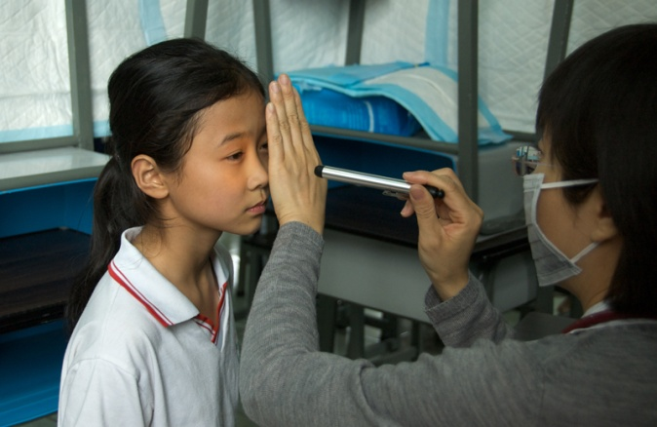 | - What do other stakeholders want or need?
 | - How would these modules affect them?
 | - How could this affect patients, community groups, government, universities, and other organizations?
 | - What organizational resources or impediments should be factored in?
 | - Who else should be consulted?
 | - What will you ask them?
Update the following Needs Analysis Table with your answers.

Needs Analysis Table (Context)
Current Situation | Gap / need | Ideal Situation
What is the current situation? |  | What would the ideal (or much better) situation look like?
Who is affected?  What are the different stakeholders doing? (patients, healthcare professionals, society) |  | What would/should the different stakeholders be doing?
What other factors are contributing to the current situation? |  | What other factors could contribute to a solution?

c) Describe Your Target Learners
Identify: what are their skills, attitudes, goals, needs? Answer as many of the following questions as are relevant to the project.

Instructions:
Aside from clinical knowledge, consider other aspects that could impact the current situation and influence the format of the program.

Some questions you can ask include:
- Entry-level skills - what can they do before the lesson...?
- What do they see as the gap in terms of the subject of the learning activity?
- What are their preferences (for learning, times, frequency, size, difficulty, etc.)?
- Motivation (what will get them going; intrinsic, extrinsic)?
- What barriers or enabling factors should be considered?
- Other...?

Learners – aspects that could impact the teaching and learning
Entry-level skills (what they can do before the lesson):

Barriers, enabling factors:

Attitude, motivation, etc.:

Other:

d) Write a Synthesis of the Gap or Need

Instructions:
Based on the above analysis, write out the gap or need in the middle column of the Needs Analysis table.
- Select the most important and most appropriate elements to include in the “Module Design Template” near the end of the workbook.

Findings – synthesis:

2. Learning Objectives

Instructions:
- Using your needs analysis and description of the gaps and ideal or improved situation, write learning objectives for your program.
- Transfer your learning objectives to the “Module Design Template” on page 18.

See: Writing Learning Objectives for CPD Programs, at the end of this workbook.

3. Demonstration of Learning
For each learning objective, what would the learners demonstrate or do for you to know that they attained the objective?
- Transfer your Demonstrations of Learning to the Module Design Template

Describe: what would learners have to demonstrate to show they "got" it?
- What would you be seeing, hearing?

For more detail, categorize that performance or demonstration. For each performance that you want to observe, what characteristic(s) would best be linked with it? Perhaps a combination of...
- Cognitive, knowledge, (remember, evaluate, create...)
- Motor skills, (type, draw, speak, click...)
- Attitude (confidence, empathy, skepticism, etc.)

4. Learning Formats – Teaching and Learning Activities
- What do the learners have to practice or do for them to reach the objective?
- Based on your reflection, describe some activities that will help the learners attain the learning objectives
- Input the activities into the Module Design Template

Lesson Plan: Sample Instructional Design Template
Look at the sample instructional design template, following the module design template, in this guide. The questions and table are offered as a means of helping you plan the structure and shape of your lesson or module.

Module Design Template

Module / topic:
Needs Analysis / Gap | Learning Objective(s) | Demonstration of Learning | Teaching and Learning Activities | Evaluation

Sample Instructional Design Template and Storyboard
Title /topic | What are you going to cover?

Learning Objective(s)
Content | Take the time to organize the lesson into different sections or sub-sections. In the space below, indicate the main sections of your lesson.  - Introduction? (You can use your needs analysis to describe the context for the lesson)  - Main body (divided into steps)?  a)  b)  - Conclusion or synthesis?  - Exercises to evaluate performance or abilities (before, during, after?)
Resources | What will you give them?  Text, images, video, articles, case studies, problems to solve, etc.
Activity(ies) | What will they do?  (Read, view, listen to..., access)  (Assess, select, create...)  (Solve, practice, explain…)
Assessment and Feedback | What assessment tools will you use?  What feedback will you give them?
Reflection and Response | How will you encourage reflection, self-assessment, and self-motivated response?
Questions and Discussions | What will you offer for discussions, questioning (peer-to-peer or with experts)?
Follow-up | What about at the end of the module?  What do you expect or hope for from the learner?  How to encourage it?
Evaluation (course level) | Insert a survey

Writing Learning Objectives for CPD Programs
All accredited CPD programs and sessions must have clear and observable learning objectives. Let’s start with defining a learning objective.

Definition of a learning objective

A Learning objective is a description of the skills, abilities and/or attitudes expected of the participant by the end of the program, session or learning activity.
NOTTTTTTTTTTTTTTTT…
“What would you like to teach your participants by the end of your session?”

Purpose of learning objectives
- They help you as a presenter or as a program planner, because they provide a focus and parameters around your presentation or program.
- They provide a cognitive map for your participants.
- They help the participants to organize information, assess their progress, and support them in achieving those objectives.

The Essence
The learning objective should describe what the participant will be able to
- DO at the end of the session
Or
- DEMONSTRATE at the end of the session

Common Errors
The most common errors in writing learning objectives are:
- Describing what the presenter will do, rather than what the participant will be able to do at the end of the session.
- Using a fuzzy, non-observable action verb, such as “understand”, “know”, “appreciate”, “value”, etc. Refer to The Sinister Sixteen in this document for a list of the verbs to avoid.

Consider this scenario…
Just imagine it is the end of the lesson and you turn to a participant and say: “Dr. X, could you please… (Insert your learning objective)”
- What would you want to see your learners doing?
- Consider the needs assessment; what is needed to answer the challenge?
- If you did write “understand” or “appreciate”, etc., what did you really mean they would DO with that understanding or appreciation?

Resources
Bloom’s Taxonomy (below) is a useful tool for considering the level of cognitive challenge that you want your participants to reach.
Review the need for the topic, the need for the learning activity and reflect on the type of outcome that would best suit that need or fill that gap.
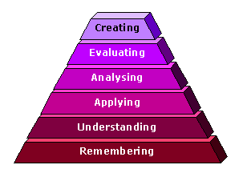
Revision of Bloom’s taxonomy of the cognitive domain following Anderson and Krathwohl (2001)

Verbs to Use in Writing Learning Objectives
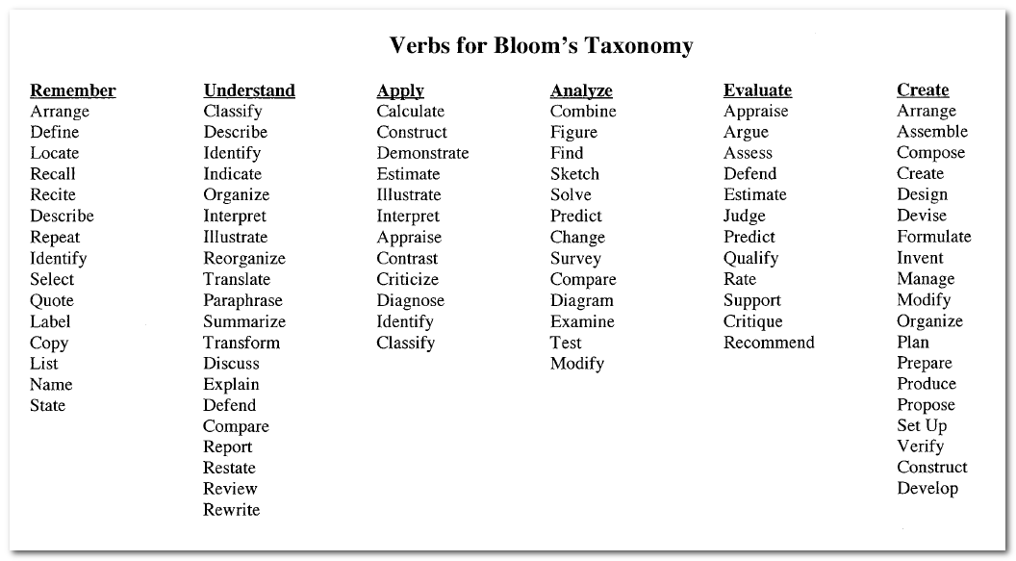

The Sinister 16!!! Vague Verbs to Avoid
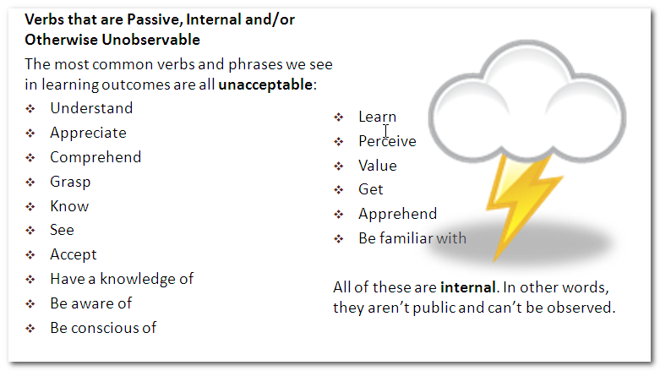

Behaviour Changing Techniques (Abraham, Michie): When developing your program, it is worthwhile to consider including various opportunities to enable practice change. The following provides some general types of behavioural change techniques that could be introduced either by the planning committee within learning objectives or as a guide to speakers/facilitators when they are developing their sessions: 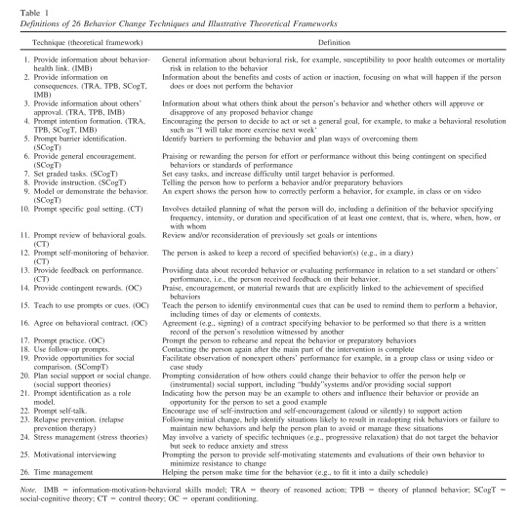

References
- Abraham C, Michie S. A taxonomy of behaviour change techniques used in interventions. Health Psychology, 2008, 27:379-387
- Anderson, L.W., & Krathwohl (Eds.). (2001). A Taxonomy for Learning, Teaching, and Assessing: A Revision of Bloom's Taxonomy of Educational Objectives. New York: Longman. Available at: http://www.jstor.org/stable/1477405?origin=JSTOR-pdf
- Diamond, Robert M. (1998) Designing and Assessing Courses and Curricula: A Practical Guide. Jossey–Bass (San Francisco)
- Forsetlund L, Bjorndal A, Rashidian A et al. (2009) Continuing education meetings and workshops: effects on professional practice and health care outcomes. Cochrane Database Syst Rev 2009; 2: CD003030.
- Kern, D.E., Thomas, P.A. and Hughes, M.T. Curriculum Development for Medical Education: A Six Step Approach (2009) Second Ed., the Johns Hopkins Univ. Press. (Baltimore)
- Knowles, M. S., Holton, E. F., & Swanson, R.A. (1998).A theory of adult learning: Andragogy. In The adult learner: The definitive classic in adult education and human resource development (5th ed., pp. 35-72). Woburn: Butterworth Heinemann.
- McMaster University Faculty of Health Sciences Continuing Health, Sciences Education Program (2009)Guidebook for Planning and Delivering Continuing Professional Development Programs and Events,pp. 9-11
- Michie S, Johnson M, Abrahm C, Lawton R. Parker D, Walker A, on behalf of the “Psychological Theory” Group. Making psychological theory useful for implementing evidence based practice: a consensus approach. Qual Saf Health Care 2005;14:26-33.
- Moutrie, R. R. and Lockyer, J. (1996), Continuing medical education handbook: A resource for CME practitioners. Stephen Biddle and Barbara B. Huffman. J. Contin. Educ. Health Prof., 16: 125–126. doi: 10.1002/chp.4750160209
- Retrieved and adapted from Royal College of Physicians and Surgeons of Canada http://www.royalcollege.ca/portal/page/portal/rc/common/documents/cpd_accreditation/learning_formats_e.pdf
- Royal College of Physicians and Surgeons of Canada (2014) Identifying the educational needs of the target audience

