Storyboard Example: Preventing Diabetic Retinopathy
Contents
Example of a Storyboard: 1
About this document 2
Getting Started 2
Splash page 2
Welcome page 3
Diabetic Retinopathy, an Introduction 4
Blank Template 6
Questions? Contact Us 7

Example of a Storyboard:
This template is to be used as an on-going repository of all elements that are part of the program. This particular storyboard was used for Preventing Diabetic Retinopathy online program.

Please see: Continuing Professional Development's Online Courses and Modules on the OCPD website.

A storyboard is an essential communication tool when working with a number of partners who are developing an online course. The storyboard serves as a common map for all members of the development team, so that all can see the pieces that will be part of the complete module. Therefore, any change that is to be made to the module should be done in the storyboard first.
The storyboard includes:
- A separate section for each page;
- A visual image for each page; and
- All the elements that will be part of the page.

About this document

Please note: highlighted sections in this document are comments or descriptions rather than what will actually appear on the page.

The texts and images shown as example are from the Preventing Diabetic Retinopathy online course produced by the Eastern Ontario Health Unit, the Champlain LHIN and the University of Ottawa’s Office of Continuing Professional Development.

The first few pages show how the template is used.

The last couple of pages contain a blank template that you may you use for your own projects.

Getting Started

Splash page

The Splash page includes:
- Navigation text. It is highlighted on the left.
- Title of the different parts.
- Branding and logos.

Wireframe image – This is a simple representation of the architecture of the screen layout. It depicts all the elements that will appear in an organized fashion. This may change as the course is being designed.
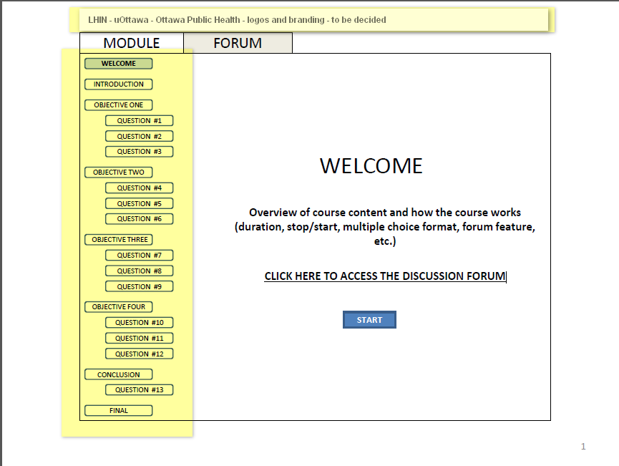

Welcome page

The Welcome page may be the same as the Splash page, or it may only hold the navigation and “how to use it” information.
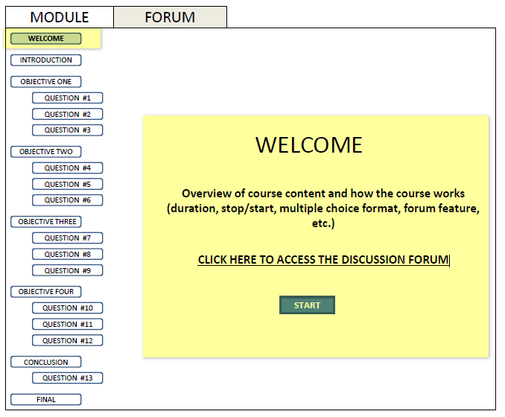

Heading | WELCOME
Text | Overview of course content  - condense the 1st paragraph of script  Diabetic retinopathy is the leading cause of legal and functional blindness for persons between the ages of 25 and 75 worldwide. In Canada, it’s expected that all patients with type 1 diabetes and more than 60% of patients with type 2 diabetes will develop some form of retinopathy in the first two decades following the diagnosis of diabetes. However, early screening and assessment with regular follow-up can lead to prompt diagnosis and successful treatment of this debilitating condition.  + add something like “in this course we will..” describe the situation and help you integrate new ways of proceeding into your practice.”-  How the course works (duration, stop/start, multiple choice format, forum feature, etc.) - tbd once the course is more developed (Bob, Gretchen)
Links | CLICK HERE TO ACCESS THE DISCUSSION FORUM  START
Video
Image(s)
Questions and response
Resources | List with any urls
Misc.

Diabetic Retinopathy, an Introduction

Same outline for a lesson.
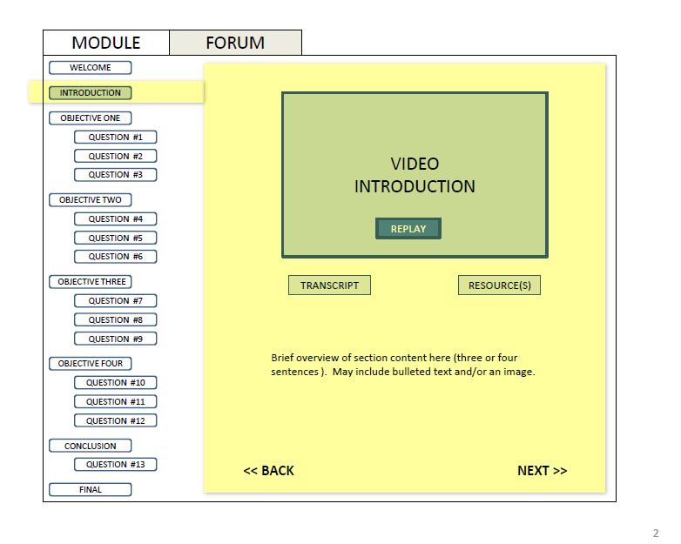
Heading | Diabetic Retinopathy, an Introduction
Text | Onscreen  Brief overview of section content here (three or four sentences). May include bulleted text and/or an image.  A summary of the introductory text ?  The program learning objectives:  By the end of this program participants will be able to:  - Describe the current concerns, challenges and barriers regarding screening for eye disease in people living with diabetes.  - Explain the retinal assessment process and related costs for the patient.  - Explain the Eye Health Council of Ontario guidelines for retinopathy assessment related to referral and follow-up practices.  - Choose communication tools that support inter-professional practice.
Links | Transcript  Resources  Back  Next
Video | Introduction: filename =
Image(s) | tbd
Transcript | VO: Diabetic retinopathy is the leading cause of legal and functional blindness for persons between the ages of 25 and 75 worldwide. In Canada, it’s expected that all patients with type 1 diabetes and more than 60% of patients with type 2 diabetes will develop some form of retinopathy in the first two decades following the diagnosis of diabetes. However, early screening and assessment with regular follow-up can lead to prompt diagnosis and successful treatment of this debilitating condition.  The objectives of this program are to help physicians to be able to:  - Describe the current concerns, challenges and barriers regarding screening for eye disease in people living with diabetes.  - Explain the retinal assessment process and related costs for the patient.  - Explain the Eye Health Council of Ontario guidelines for retinopathy assessment related to referral and follow-up practices.  - Choose communication tools that support inter-professional practice.
Questions and response
Question 1  Stem | What is the leading cause of vision loss in patients 25-74 years of age world-wide?
Distractors (with Key) | - Cataracts  - Glaucoma  - Diabetic retinopathy  - Eye infections
Explanation and references | Diabetic retinopathy is the most common cause of new cases of legal blindness in people of working age.  (1) Klein R, Klein BEK (1995).  (2) Ontario Ministry of Health and Long-Term Care (2004).
Resources | List with any urls
Misc.

Blank Template

Name of course
Section (or lesson) of course
Screen Image

Heading | Title, sub-title
Text | Learning objectives  Summary  Full text  Etc
Links | To files, video, images, other sites, etc.
Video | If applicable.  Brief description, filename(s).
Image(s) | If applicable.  Brief description, filenames.
Transcript | Complete
Questions and response | Complete
Question 1  Stem | …?
Distractors (with Key) | - Key (answer)
Explanation and references | Text………………………………………..  (1) reference  (2) reference
Resources | List with any urls
Misc.

Questions? Contact Us
For questions, please contact:
Bob Parson
Directeur, Formation et agrément – Director, Education and Accreditation
Tel.: 613-798-5555 Ext. / Poste 16879
Email: rparson@toh.ca

