Problem Assisted Learning (PAL)
Hypertension

This PAL is based on the following objectives:
  - Describe and demonstrate the appropriate technique for blood pressure assessment.
  - Describe the operator and patient factors that can artificially raise and lower blood pressure.
  - Define how to diagnose hypertension (HTN) in a family practice setting for different patient groups, and identify the blood pressure targets for these groups.
  - Describe the role of patient determined blood pressure and 24-hour ambulatory blood pressure assessment in the diagnosis and monitoring of HTN.
  - Describe the effects of hypertension on end-organs and how to assess a patient for these.
  - Propose an initial diagnostic workup for a patient with a new diagnosis of high blood pressure to determine if there is a secondary cause for hypertension (versus essential hypertension).
  - Define the diagnostic and treatment targets for various groups of patients with high blood pressure.
  - Propose a treatment plan (incorporating non-pharmacologic and pharmacologic options) for a patient with a new diagnosis of high blood pressure.
  - Recognize and act on a hypertensive crisis.
  - Describe the various drugs classes used to treat high blood pressure and their mechanisms of action, side effects, relative cost, and pharmacokinetics.

Session Structure
The larger group is to be divided into three smaller groups. Each group will be given a short case. They are to develop the rest of the history and physical, and subsequently come up with the diagnosis, investigations and management on their own. The short version of the case will then be presented to the rest of the group. The rest of the group will have to ask the appropriate history and physical questions, ask for investigations done and results, and come up with the differential diagnosis, actual diagnosis, and management. The group leader will facilitate this and this model will be used for all three cases.
Case #1:
A 20-year-old female comes into your office saying she is worried about her BP. She joined a gym, and found her BP to be 155/90. She repeated this on three separate days and the readings were 160/100, 150/80 and 145/95. She is otherwise healthy, on no medications, and no significant family history. In office today, her BP is 145/95 and her BMI is 32. Please proceed as instructed above.

Case #2:
A 45-year-old male come into your office for a routine physical. His BP is 153/95. He has a family history of hypertension. Please proceed as instructed above.
Case #3:
A 70-year-old male comes into your office complaining of a headache. His BP is 220/138. He is a smoker with a family history of CAD. He has been taking 60mg of Celexa for the past 3 years. He feels unwell. Please proceed as instructed above.
AREAS TO COVER (For group leader)
HISTORY:
ROS:
History of headache, visual changes, chest pain, dyspnea, leg swelling, neurological deficits, vertigo, exertional calf pain, PND, snoring and sleep apnea, palpitations, excessive sweating, weight changes

PMHx:
History of CAD, PAD, CKD, DM2, dyslipidemia, obesity, cognitive changes, OSA

Medications:
Use of NSAID, COX inhibitors, anabolic steroids, corticosteroids, SSRI’s, SNRI’s, OCP’s, decongestants

Social history/ Dietary:
Ask if smoker, ask about salt intake, drug use (cocaine), excessive alcohol use, exercise, diet

Family history:
Ask if: family history of HTN, CAD, PAD, stroke, renal artery stenosis, hyperaldosteronism, pheochromocytoma, coarctation of aorta

PHYSICAL EXAM:
-How to take a BP: Refer to CHEP Guidelines (TABLE S2) - http://guidelines.hypertension.ca/diagnosis-assessment/supplementary-tables/

- Take BP in both arms
- Check for abnormal cranial nerve exam, papilledema, cotton wool spots, retinal hemorrhages, heart murmurs, renovascular bruits, carotid bruits, decreased or absent peripheral pulses, extremity swelling

INVESTIGATIONS TO ORDER FOR ESSENTIAL HYPERTENSION:
- Urinalysis
- Fasting blood sugar
- Electrolytes and creatinine
- Fasting lipid profile
- ECG
- Urine ACR

INVESTIGATIONS TO ORDER TO R/O SECONDARY HYPERTENSION
- TSH
- Calcium, albumin, PTH
- Renal U/S
- Dexamethasone suppression test
- Sleep study
- Plasma aldosterone: plasma renin ratio
- Urine for metanephrines
- Echocardiogram

HOW TO MAKE DIAGNOSIS OF HYPERTENSION?
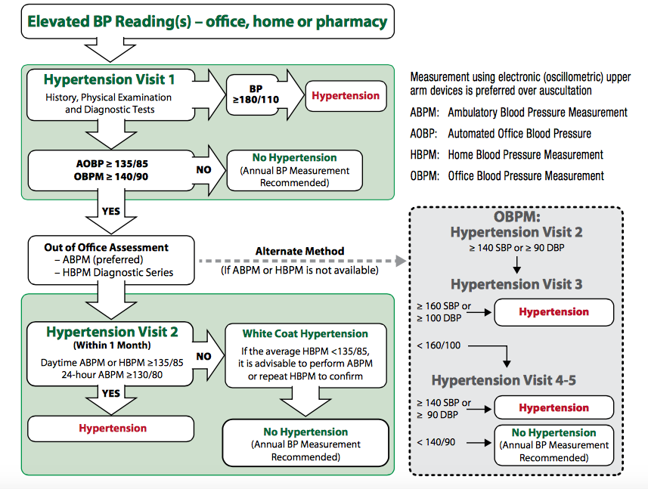
Figure above from: http://www.onlinecjc.ca/article/S0828-282X(15)00130-0/pdf
EXAMPLES OF TARGET END ORGAN DAMAGE:
- Stroke
- Dementia
- Hypertensive retinopathy
- LVH
- CAD-MI, angina
- CKD -eGFR less than 60 or albuminuria
- PAD- intermittent claudication
RISK FACTORS FOR HYPERTENSION
- Age >55
- Male
- Family history
- Smoker
- Obesity
- Poor diet
- Dysglycemia
- Stress
- Non-adherence
CAUSES OF SECONDARY HYPERTENSION
- Renal artery stenosis
- Sleep apnea
- Hypothyroidism, Hyperthyroidism
- Coarctation of aorta
- Hyperaldosteronism
- Cushing’s disease
- Hyperparathyroidism
- Drug side effects (as above)
WHAT IS A HYEPRTENSIVE URGENCY/EMERGENCY
Urgency:
Asymptomatic diastolic BP ≥ 130 mmHg

Emergency:
Hypertensive encephalopathy
Acute aortic dissection
Acute left ventricular failure
Acute myocardial ischemia
Acute kidney injury
Intracranial haemorrhage
Acute ischemic stroke
Pre-eclampsia/eclampsia
Catecholamine-associated hypertension

DISCUSS NON-PHARMACOLOGICAL INTERVENTIONS FOR HTN
- Physical exercise
- Weight reduction
- Decreasing ETOH consumption
- DASH diet
- Decreased salt intake
- Stress management
DISCUSS PHARMACOLOGICAL INTERVENTIONS FOR HTN-- Refer to http://guidelines.hypertension.ca/prevention-treatment/uncomplicated-hypertension-therapy/
- ACE/ARB (cough, hyperkalemia, decreased renal function)
- Diuretics (hypokalemia)
- CCB- leg swelling
- Beta Blockers- fatigue, bradycardia

TREATMENT TARGETS
- Systolic blood pressure treatment goal is a pressure level of < 140 mm Hg
- Diastolic blood pressure treatment goal is a pressure level of < 90 mm Hg
- In the very elderly (≥ age 80 years), the systolic BP target is < 150 mm Hg
- Persons with DM should be treated to attain SBP of <130mmHg and DBP of <80mm Hg
- Persons with a history of CVD and/or non-diabetic CKD should be treated to attain SBP of <140mmHg and DBP of <90mmHg
References:
CHEP GUIDELINES: http://guidelines.hypertension.ca

